Research Question:
How Does Acute Anthropogenic Noise Pollution Induce Physiological Stress in Hemigrapsus oregonensis? (Hairy shore crabs)
Hypothesis:
Ho: Acute anthropogenic noise pollution has no effect on the physiological stress response of hairy shore crabs.
Ha: Acute anthropogenic noise pollution has a significant effect on the physiological stress response of hairy shore crabs.
Key Figures and Takeaways:
Resazurin Figures
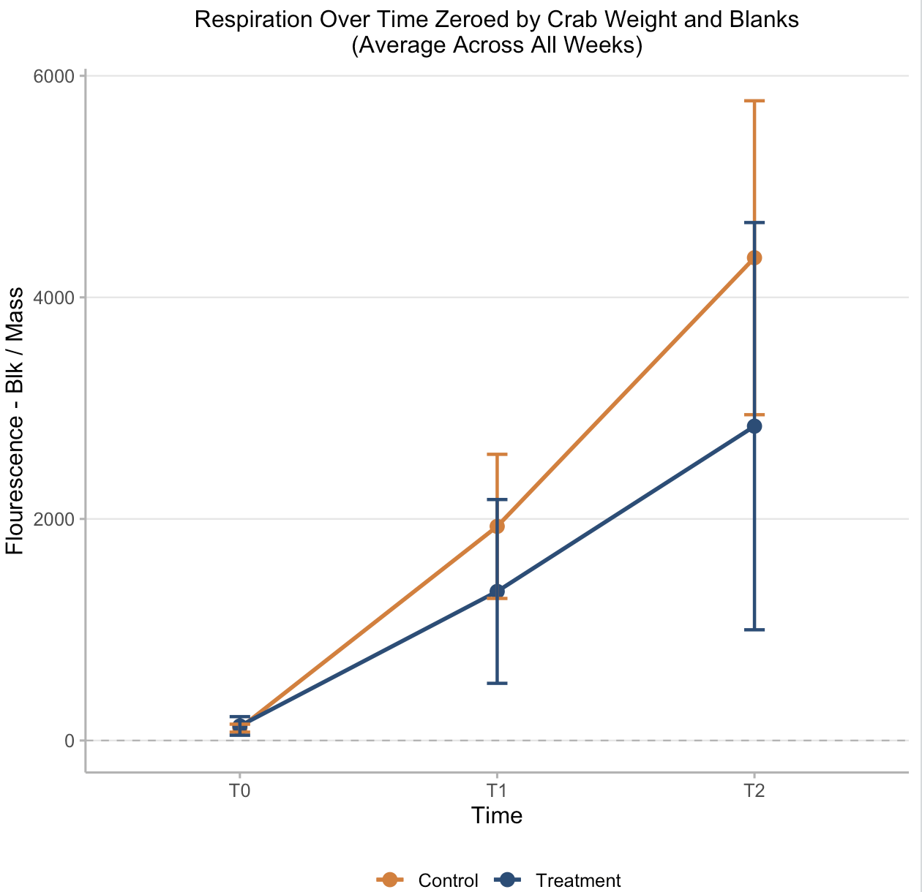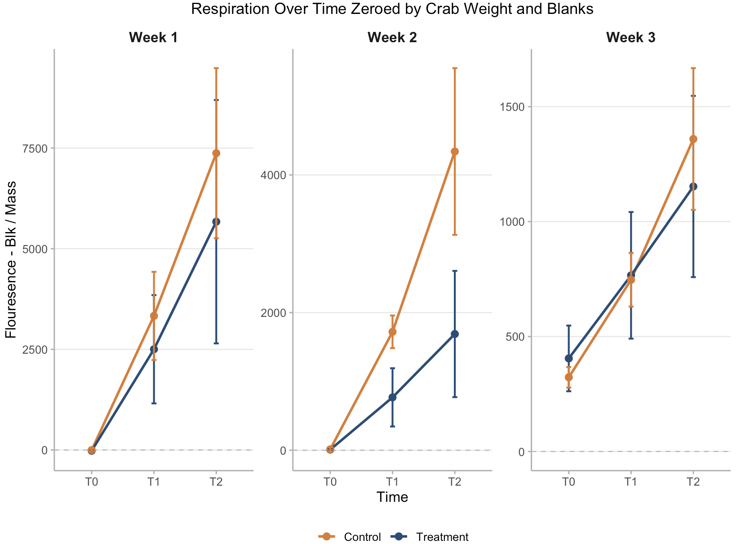
We see that when results were averaged between all weeks, crab respiratory response to ~75 decibels of acute anthropogenic sound were not statistically significant but followed a clear visual trend. Surprisingly, the visual trend we have observed is that we see that the crabs within the control group are respiring more than those in our treatment group. Additionally, oxygen consumption over time is non-linear. We see increased oxygen demand in the second 30 minutes of our assay in both our treatment and control crabs.
Righting Time Images

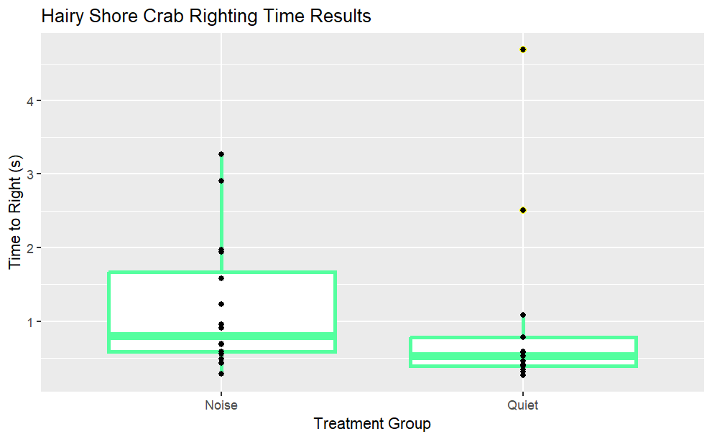
We see a significant difference in the Righting Time of the Noise (experimental) group and Quiet (control) group. There is an outlier of 46.81 seconds for Blue 13 in the Noise (experimental) group during Week 2, as well as Blue 12 (Noise-experimental) at 56.24 seconds during week 3. Crabs from the Noise group had a longer Righting Time than the Quiet group.
Discussion:
Righting time values could be in response to disorientation from the high decibel and bass from the speaker after two hours of exposure to house/edm .

Glucose Assay Images
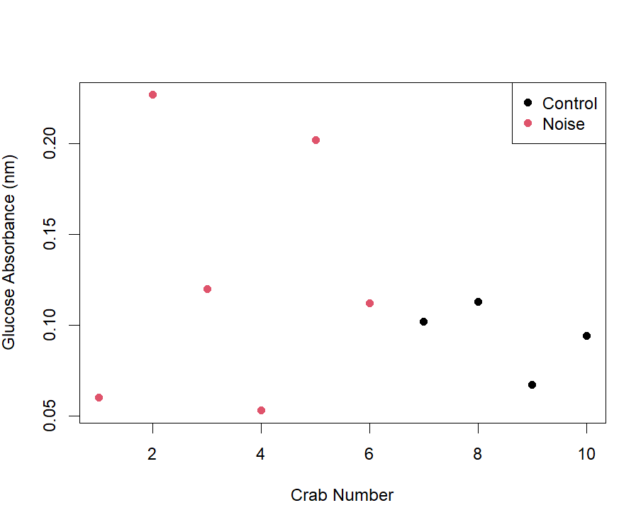
We notice a much larger spread in the absorbance of the experimental crabs than we do when compared to the control group, with the more dramatic end being the high absorbance. Not much of a clear conclusion can be drawn, but it is possible yet again that the experimental group was not as stressed as the control group.

